

THE OKLAHOMA PIPELINE ENERGY STORAGE SYSTEM (OPESS) Risk report

By Jonathan Grinnell

FALL 2022



EN.645.800

Mentor Robert Krzystan

|  |  |  |
| --- | --- | --- |
| Document Name | Date | Reason for Change |
| Grinnell_Risk | 11/19/22 | Initial Document |

Contents

Table of Figures 3

Table of Tables 3

1 Risk Report Description 4

2 OPESS ConOps 5

2.1 System Need 5

2.2 System Block Diagram 5

2.2.1 OPESS Block Diagram 6

2.2.2 ESS Block Diagram 6

2.2.3 CaCS Block Diagram 7

3 Risk 9

3.1 Risk Analysis Methods 9

3.2 Risk Summary 10

3.3 Risk 1: Weather 10

3.4 Risk 2: Earthquake 11

3.4 Risk 3: Residual Natural Gas 12

3.5 Risk 4:Cyber Security 13

4 Earned Value Management 15

4.1 Schedule 15

4.2 Milestones 15

4.3 EVM 15

4.4 CPI and SPI Index 16

5 References 16

# Table of Figures

Figure 1: OPESS Block Diagram End of Risk Version 6

Figure 2:ESS Block Diagram End Risk Version 7

Figure 3: CaCS Block Diagram End of Risk Version 8

Figure 4: Risk Chart Example 9

Figure 5: Risk 1 Weather 11

Figure 6: Risk 2 Earthquake 12

Figure 7: Risk 3 Residual Natural Gas 13

Figure 8: Risk 4 Cyber Security 14

# Table of Tables

Table 1: MOE Summary 4

Table 2 List of Solution Needs 5

Table 3: Program Risk Summary 10

Table 4: Risk 1 Requirements 11

Table 5: Risk 2 Requirements 12

Table 6: Risk 3 Requirements 13

Table 7: Risk 4 Requirements 14

Table 8: Milestones 15

# 1 Risk Report Description

The **Risk report** will be delivered as the eighth delivery of the **Oklahoma Pipeline Energy Storage System (OPESS)**. This report will be composed of a Concept of Operations as well as an analysis of the risk associated with the system. Schedule, EVM and CPI/SPI will also be discussed during this project.

The concept of operations will provide a description of the functional need that the OPESS aims to fill. It will focus on spelling out the current makeup of the Oklahoma power grid, its increasing reliance on renewable sources of energy and why a new energy solution will be needed to meet future demand. After that, the ConOps will dive further into the design of the OPESS system through the use of block diagrams in an attempt to flesh out the two subsystems that compose the OPESS.

The risks, as discussed in section 3, will provide a detailed analysis of the risk and what has been done about them as they have been tracked throughout the course of the OPESS deliveries.

This document will also provide an update of the EVM as it stands as of this writing. Schedule updates, deliveries, the WBS and SPI/CPI will be discussed in this section.

All KPP’s listed in section 3 trace to MOE 2 through MOE 4. These MOEs can be found in the table below. These remain unchanged from the RAR.

Table : MOE Summary

| MOE Number | Summary |
| --- | --- |
| MOE 1 | The energy efficiency of the OPESS must be high enough to be of worth to the market. |
| MOE 2 | The ESS must be able to store energy on the time span of months to years. |
| MOE 3 | The OPESS much adhere to proper cyber security standards. |
| MOE 4 | The ESS should be able to stand up to the elements. |
| MOE 5 | The OPESS must not produce carbon emissions. |

MOE 1 was left was not referenced by the KPPs since that particular MOE is really more of a market and financial requirement. This MOE is still an important one to have listed and reference as this requirement will ultimately be what decides the viability of the OPESS system.

# 2 OPESS ConOps

## 2.1 System Need

In 2010 Oklahoma mandated that 15% of the state’s energy needs be provided by some form of renewable energy source. As early as 2012 the state surpassed that goal (Popovich & Plumer, 2020). In 2021, the amount of energy produced by renewable sources accounted for 45% of the state’s energy needs. That number continues to increase as new wind projects are stood up and roof top solar becomes more popular. Unfortunately, wind and solar are not a source of consistent power. When the sun goes down homeowners are forced to either pull power from a grid that still produces energy primarily from dirty sources or from an expensive battery pack. High pressure systems can also move in, causing time periods of low wind energy production or worse yet, strong winds can come in during storm season and produce an excess of wind energy, forcing wind turbines offline.

The solution is to install large amounts of grid level energy storage. This will help even out the peaks and valleys of energy production, allowing energy produces on high energy days to be used on low energy days. Batteries are expensive and will compete with electric cars as their demands rises and pumped hydro can’t really be used in Oklahoma as the state neither gets the required amount of rain or has enough in the way of mountains to make it practical.

What the state does have in abundance are natural gas wells. It is through the use of this resource common to the state that a form of green energy storage can be developed. A list of solution needs can be found is table 2.

Table List of Solution Needs

|  |  |  |
| --- | --- | --- |
| Number | Name | Description |
| 1 | Extra Storage | The OPESS needs to be able to store extra energy from renewable sources during times of over production. |
| 2 | Low-Cost Storage | The OPESS needs to be able to store energy produced on the grid during low rates for use during times of high rates |
| 3 | Long Term Storage | The OPESS needs to be able to store energy for a significant amount of time with minimal loss. This will be measured on the timeframe of months to years. |
| 4 | Grid Scale Storage | The OPESS needs to be able to provide an energy storage solution that can be maintained on a grid level. |

## 2.2 System Block Diagram

The system block diagrams were produced during the RAR. They have been modified a bit as the design of the OPESS has changed though they have remained relatively intact for the most part. The block diagrams can be found in the sections below.

### 2.2.1 OPESS Block Diagram

The OPESS is composed of two major subsystems. The first is the Energy Storage Subsystem (ESS). The ESS is the actual storage system of the OPESS system. Functionally, it pulls power off the grid, compressed air for storage in spend natural gas wells, and then used that gas to spin a turbine for use on the grid. Since this device is outside, it is exposed to the elements and will thus need to be protected.

The second major subsystem is the Command-and-Control Subsystem (CaCS). As its name suggests, it performs the command-and-control functionality of the OPESS system. The CaCS allows communication between the OPESS and other utility companies and plants that might be powering the grid at the time. The CaCS communicated with the ESS over a secured internet connection.

Figure : OPESS Block Diagram End of Risk Version

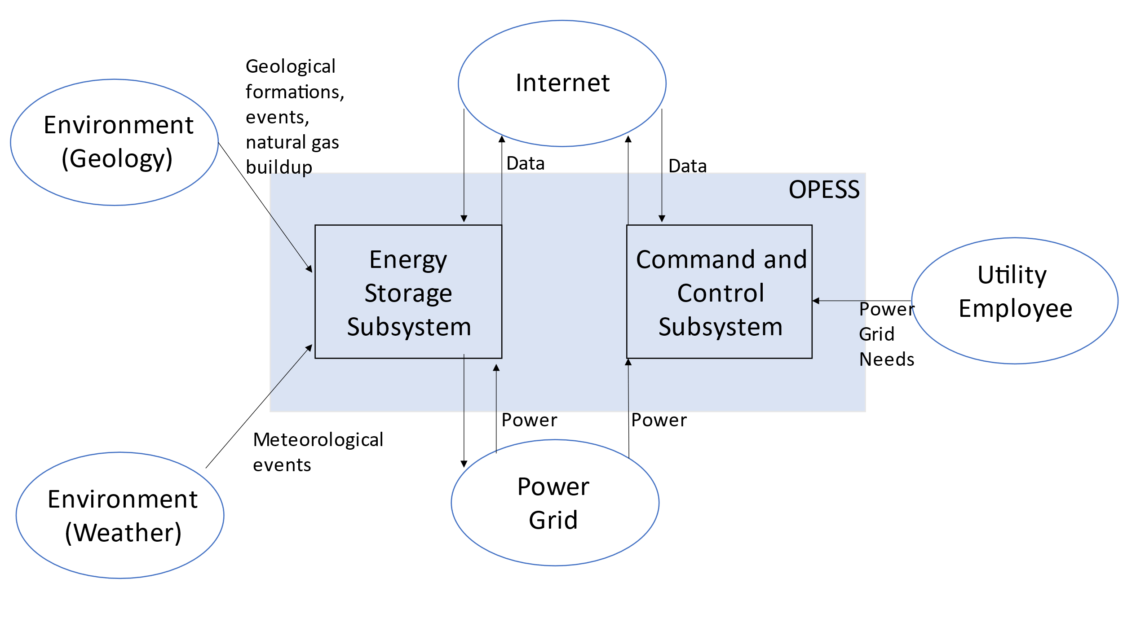

### 2.2.2 ESS Block Diagram

The ESS is the heart of the OPESS. It is composed of 5 functions, receive power, store power, generate power, a control node and weather protection. The primary function of the ESS is to act as a battery, hence the first three functions, however, unlike a batter, this is a complicated piece of equipment with lots of moving parts. A localized control note will have to be included in order to tell the individual components of the ESS how to behave. Additionally, this node will communicate with the CaCS and report and health and status issues the ESS might be experiencing.

Additionally, per risk 1, the ESS will be exposed to the elements on a regular bases and Oklahoma is famous for its bad weather. The final function, weather protection, is a risk reduction function meant to protect the ESS.

Figure :ESS Block Diagram End Risk Version

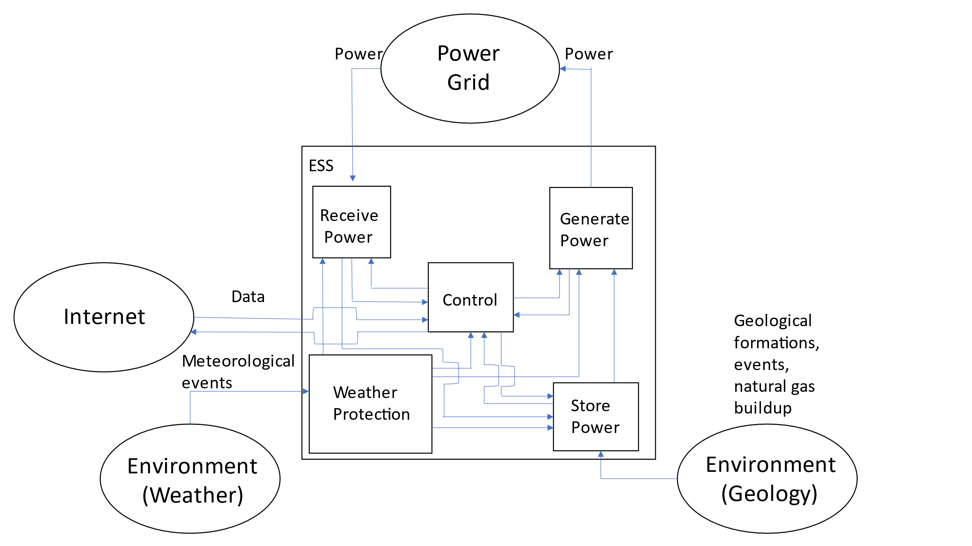

### 2.2.3 CaCS Block Diagram

The CaCS is the brains of the OPESS system. It exists primarily as an office space that allows utility workers, economists and engineers to communicate with other facilities both locally and across state lines in an effort to figure out what the future and current electrical needs will be. The CaCS will be able to allow employees access to modeling software in an effort of predict the future needs of the OPESS system on the grid. The CaCS will also allow employees to log into the ESS from their desk, monitor health and status and even control the ESS without having to go into the field. This will be helpful as issues can be diagnosed and handled without sending out technicians into the field.

Figure : CaCS Block Diagram End of Risk Version

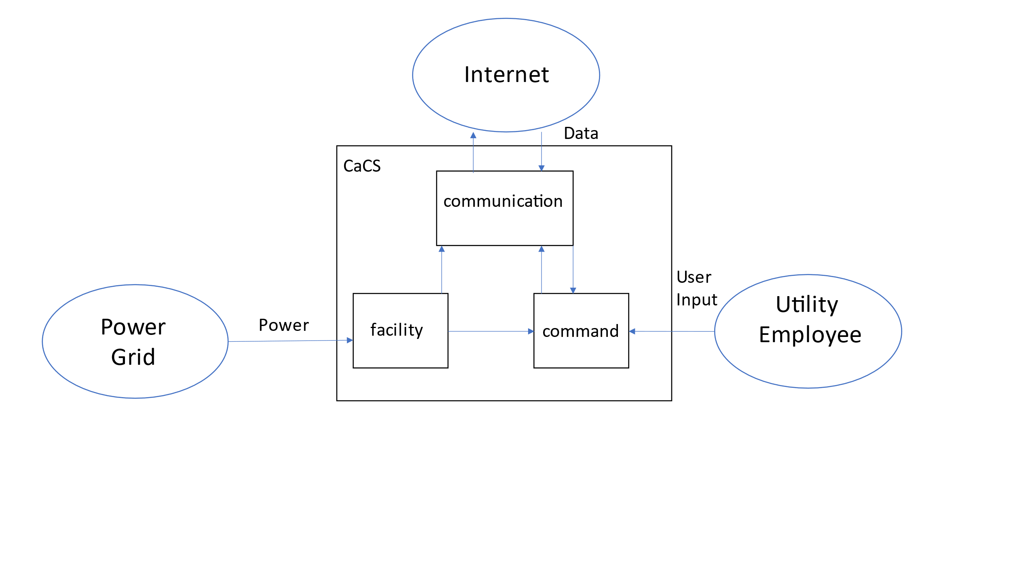

# 3 Risk

## 3.1 Risk Analysis Methods

During the course of the OPESS development, several risks were identified and tracked. The tracking of the risks utilized a risk chart that tracked each risk individually over the course of the OPESS development lifecycle. An example of this chart can be found in figure 1 below.

Each risk was allowed a unique identifier number to allow for easy and convenient identification. The type of risk was also tracked, allowing for Technical, Environmental, Cost and Schedule risk to all be present and discussed. However, the OPESS only Identified Environmental and Technical risk associated with the project. A description of the risk is also provided to provide a definition of what the risk actually is.

The standard 5 by 5 cube was used to track the risks. The consequences are set to go from 1, which is and outcome of small consequent, to 5, which is an outcome of extreme consequent. The likelihood is also defined as a linear progression of 1, being a small chance of the event happening, and 5, which is a high likelihood of the event happening. An “X” is placed on the chart to allow for tracking during each phase of development.

As mitigation steps are fleshed out, they are added to the mitigation table in the lower left. This allows for a tracking of the history and event surrounding the evolution of the risk throughout development.

Finally, the value of the consequence assigned in the cube is multiplied by the likelihood. This gives a dynamic number that can be used to track the severity of the risk throughout development. As the risk cube gets updated, so too does this value.

Figure 4: Risk Chart Example

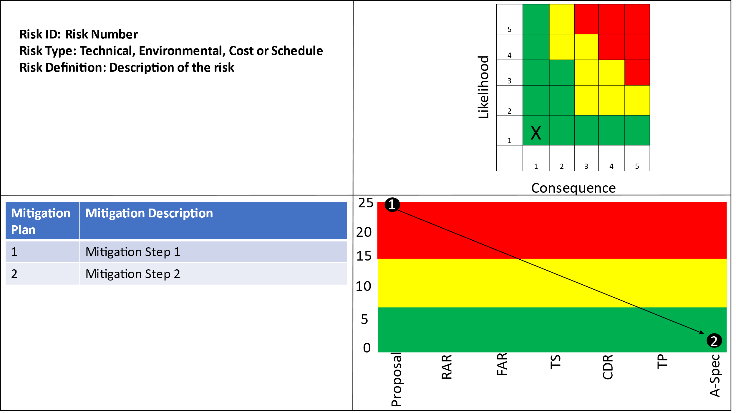

## 3.2 Risk Summary

Over the lifetime of the OPESS development, four risk have been tracked. A summary of the evolution of these risks can be found in table 3 below.

Table : Program Risk Summary

|  |  |  |  |  |  |  |  |  |
| --- | --- | --- | --- | --- | --- | --- | --- | --- |
| Risk ID | Risk Name | Risk Definition | Original Consequence | Original Likelihood | Original Score | Final Consequence | Final Likelihood | Final Score |
| Risk 1 | Weather | If severe weather arrives, like large hail or a tornado, then the ESS could be at risk of damage or compressed air leakage. | 2 | 5 | 10 | 1 | 2 | 2 |
| Risk 2 | Earthquake | If an earthquake were to occur, then the ESS could be damaged and potentially leak compressed air. | 3 | 1 | 3 | 3 | 1 | 3 |
| Risk 3 | Residual Natural Gas | If natural gas is able to seep back into the well, then at pressure, the gas might react with the oxygen in the compressed air and explode. | 4 | 5 | 20 | 5 | 1 | 5 |
| Risk 4 | Cyber Security | If an adversarial group were to attack and infiltrate the OPESS network, then they would gain access to proprietary OPESS files as well as potentially damage the ESS. | 5 | 5 | 25 | 5 | 1 | 5 |

## 3.3 Risk 1: Weather

The weather in Oklahoma transition from hot summers to cold winters. Tornadoes and hail are also an ever-present threat in the state as well. As such, some form of protection from the elements was needed to insure the ESS was not damaged during severe weather. The likelihood of the ESS experiencing severe weather over the course of its lifetime is very high so the original risk was given a likelihood of 5. However, most equipment can take most of what Oklahoma has to through at it so a consequence of 2 was given. During the RAR requirements, and a whole subsystem were developed to protect against this specific risk. This risk now has a likelihood of 2 and a consequence of 1.

It is important to note though, that EF5 tornadoes are rare but do happen in the state. There is also really nothing that can be done to protect against such a tornado short of burring the ESS underground. As such, this risk can never really go to zero.

Figure 5: Risk 1 Weather

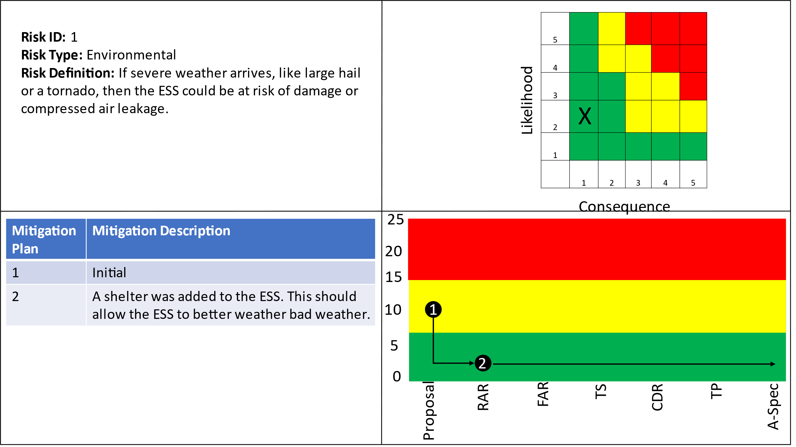

The requirements written for Risk 1 can be found in table 4 below.

Table : Risk 1 Requirements

|  |  |  |  |
| --- | --- | --- | --- |
| Requirement Number | Requirement Name | Requirement Number | Requirement Name |
| 1.1.5 | ESS Weather | 1.1.5.1 | ESS Cooling |
| 1.1.5.2 | ESS Hail | 1.1.5.3 | ESS Heating |
| 1.1.5.4 | ESS Tornado | 1.1.5.5 | ESS Wind |
| 1.1.5.6 | Weather Protect | 1.1.5.7 | Climate Control |

## 3.4 Risk 2: Earthquake

Risk 2 discusses the possible effect earthquakes might have on the natural gas wells native to Oklahoma. Oklahoma is not a state commonly associated with earthquakes, but they became more prevalent in the early 2010’s. While they have calmed down a lot since then, the possibility of another earthquake can not be discounted. As such, this risk must exist. However, a petroleum engineer is needed to really understand the geology of the state to know what effect, if any at all, these earthquakes might have on natural gas wells. As such, no modifications could be made to the OPESS to handle that particular risk. It is believed to be a low-risk item as big earthquakes (above 5.0) are extremely rare and natural gas wells seem to of survived them up until now.

Figure 6: Risk 2 Earthquake

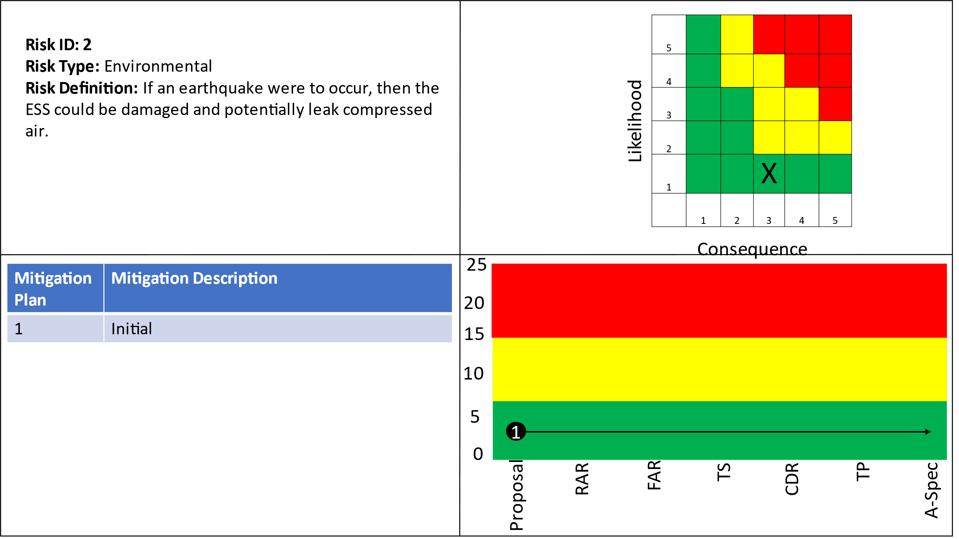

The requirements written for Risk 2 can be found in table 5 below.

Table : Risk 2 Requirements

|  |  |  |  |
| --- | --- | --- | --- |
| Requirement Number | Requirement Name | Requirement Number | Requirement Name |
| 1.1.3.1.2 | ESS Storage pressure monitoring |  |  |

## 3.4 Risk 3: Residual Natural Gas

Unfortunately, natural gas is a known flammable substance and the use of old wells opens up the ESS to a potential fiery end. As such risk 3 has to do with handling any potential explosive issues involving keeping a combustible mixture under pressure. Left over natural gas is something that may be unavoidable and more might leach into the wells as a byproduct of natural geology. As such, the likelihood of this happening was fairly high at a 4 but since this could result in the destruction of the ESS, it was given a consequence of 5. However, through research and deciding on the right requirements, the risk was brought down significantly. Unfortunately the consequence is a binary choice, the ESS either explodes or it doesn’t, so the consequence was left at a 5. However, through planning and a layered approach to safety, it is believed the gas combination can be kept from forming a combustible mixture to begin with.

Figure 7: Risk 3 Residual Natural Gas

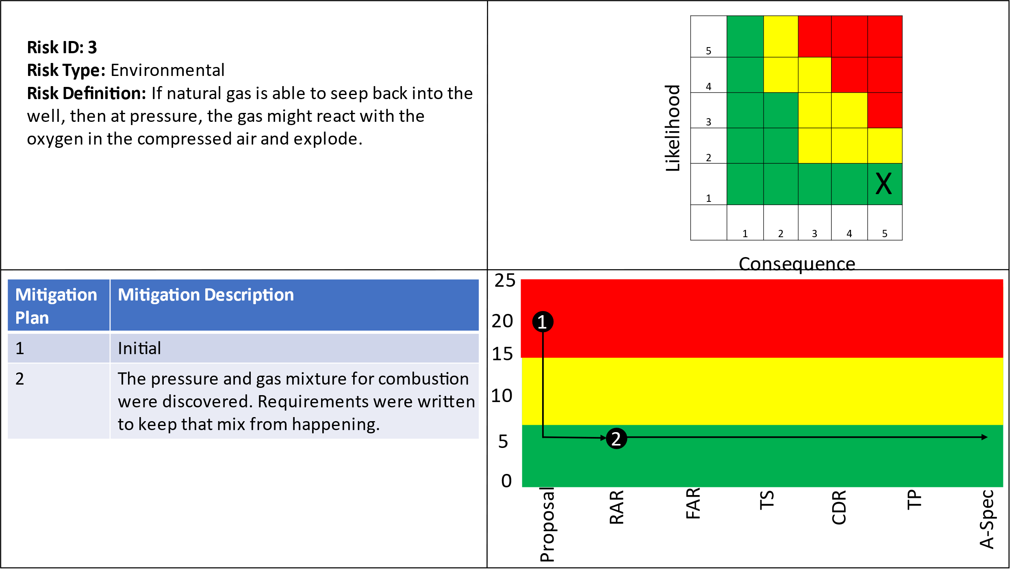

The requirements written for Risk 3 can be found in table 6 below.

Table : Risk 3 Requirements

|  |  |  |  |
| --- | --- | --- | --- |
| Requirement Number | Requirement Name | Requirement Number | Requirement Name |
| 1.1.3 | ESS Power Storage | 1.1.3.1 | ESS Compressed air monitoring |
| 1.1.3.1.1 | ESS Gas Monitoring | 1.1.3.1.2 | ESS Storage pressure monitoring |
| 1.1.3.1.3 | ESS Storage Sensors | 1.1.3.1.4 | ESS SW Max Gas mix |
| 1.1.3.1.5 | ESS SW Max PSI | 1.1.3.1.6 | Chemical Monitoring |
| 1.1.3.1.7 | Pressure Monitoring |  |  |

## 3.5 Risk 4:Cyber Security

A major risk with systems like the OPESS is that since they are connected to the power grid as a supplier, they are considered critical infrastructure. As such, they are a popular target for cyber attackers looking to make some trouble. Since the ESS communicated with the CaCS over the internet, there really is no way to make sure that the OPESS is fully isolated and protected. In other words, it will be attacked. As such, the likelihood given to this risk sit at a 5. If a bad actor were to get in, the could over use the ESS, over loading and damaging the infrastructure used to power homes and businesses. They could also under use it and draw extra power off the grid, causing brown outs. As such, this risk was given a consequence of 5 as a hack could effect more then just the OPESS.

Requirements were written in the RAR and expected to fill in that gap in capability, however, during the trade study, a redesign of the OPESS network and communication system happened as network servers were switched over to a cloud-based services. These are more secure than a local server and allow for updated and more modern security packages. The consequence of a hack is still sitting high at a 5 but the likelihood has been brought down to a 1.

Figure 8: Risk 4 Cyber Security

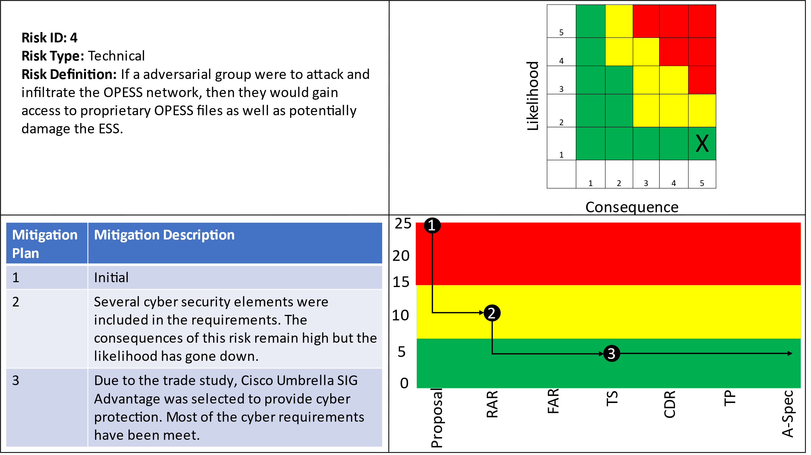

The requirements written for Risk 4 can be found in table 7 below.

Table : Risk 4 Requirements

|  |  |  |  |
| --- | --- | --- | --- |
| Requirement Number | Requirement Name | Requirement Number | Requirement Name |
| 1.1.1.5 | ESS Internet Interface | 1.1.1.5.1 | ESS Cyber Scans |
| 1.1.1.5.2 | ESS Encryption | 1.1.1.5.3 | ESS Fiber Optics |
| 1.1.1.5.4 | ESS URL Filtering | 1.1.1.5.6 | ESS TCP/IP |
| 1.1.1.5.8 | ESS Cyber Security Suite | 1.1.1.5.9 | ESS Secure Connection |
| 1.1.1.5.10 | ESS IPS | 1.1.1.5.11 | ESS TLS |
| 1.1.1.5.12 | ESS DDoS Protection | 1.2.1.1.2 | CaCS Log In |
| 1.2.1.1.3 | CaCS Ring Network | 1.2.1.1.4 | CaCS Security Scan |
| 1.2.1.1.5 | CaCS VM | 1.2.1.2 | CaCS Servers |
| 1.2.1.3 | CaCS Syber Security | 1.2.1.3.1 | CaCS Anti-Virus |
| 1.2.1.3.2 | CaCS Cyber Filtering | 1.2.1.3.3 | CaCS Firewall |
| 1.2.1.3.4 | CaCS Intrusion Detection | 1.2.1.3.5 | CaCS TCP/IP |
| 1.2.1.3.6 | CaCS IPS | 1.2.1.3.7 | CaCS TLS |
| 1.2.1.3.8 | CACS DDoS Protection | 1.2.3.1 | CaCS Control |
| 1.2.3.1.1 | CaCS ESS Health and Status | 1.2.3.1.2 | CaCS ESS Interface |
| 1.2.3.1.3 | CaCS Two Factor Authentication |  |  |

# 4 Earned Value Management

## 4.1 Schedule

Much as was said during the A-Spec, the schedule for the OPESS has been compressed due to an updated due date of 12/2. However, EVM rules keep any task that is more then current month plus one out from being updated. As such, the OPESS is currently running well ahead of schedule.

## 4.2 Milestones

Milestones Items in red were turned in late per the original due date. Green have been turned in ahead of schedule. All other deliveries are expected to be ahead of schedule.

Table 8: Milestones

| **Milestone** | **Date** |
| --- | --- |
| Project Proposal | 7/8/2022 |
| Requirements Report | 8/12/2022 |
| Functional Analysis | 9/2/2022 |
| Trade Study | 9/7/2022 |
| Concept of Operations | 10/8/2022 |
| Test Plan | 11/5/2022 |
| System Specifications | 11/17/2022 |
| Risk Management Report | 11/22/2022 |
| Final Report | 12/13/2022 |
| Oral Presentation | 12/14/2022 |

## 4.3 EVM

| WBS number | Name | % Complete | Budget | BCWP | ACWP | SPI | CPI |
| --- | --- | --- | --- | --- | --- | --- | --- |
| **7** | **Risk Management Report** | **85.71%** |  |  |  |  |  |
| 7.1 | Risk Assessment During Requirements Report | 100.00% | 2 | 2.00 | 1 | 1 | 2.00 |
| 7.2 | Risk Assessment During Functional Analysis | 100.00% | 2 | 2.00 | 1 | 1 | 2.00 |
| 7.3 | Risk Assessment During ConOps | 100.00% | 2 | 2.00 | 1 | 1 | 2.00 |
| 7.4 | Risk Assessment During Trade Study | 100.00% | 2 | 2.00 | 1 | 1 | 2.00 |
| 7.5 | Perform Final Risk Assessment | 100.00% | 2 | 2.00 | 5 | 1 | 0.40 |
| 7.6 | Turn in Final Risk Assessment | 100.00% | 0.5 | 0.50 | 0.3 | 1 | 1.67 |

## 4.4 CPI and SPI Index

# 5 References

*Electricity explained: How electricity is delivered to consumers.* (2022, August 11). Retrieved from US Energy Information Administration: https://www.eia.gov/energyexplained/electricity/delivery-to-consumers.php

Grubelich, M. C., Bauer, S. J., & Cooper, P. W. (2011, September). *Potential Hazards of Compressed Air Energy Storage in Depleted Natural Gas Reservoirs.* Retrieved from Sandia Report: https://www.osti.gov/servlets/purl/1029814/

Popovich, N., & Plumer, B. (2020, 10 28). *How Does Your State Make Electricity?* Retrieved from The New York Times: https://www.nytimes.com/interactive/2020/10/28/climate/how-electricity-generation-changed-in-your-state-election.html

*The Basics of Underground Natural Gas Storage* . (2015, 11 16). Retrieved from US Energy Information Administration: https://www.eia.gov/naturalgas/storage/basics/

U.S. Energy Information Administration. (2022, May 19). *Oklahoma State Profile and Energy Estimates*. Retrieved from U.S. Energy Information Administration: https://www.eia.gov/state/analysis.php?sid=OK